**Certificate Course On Gen AI**

**Module-1 Submission**

==========================================================================

**ID = 24MCA014**

**Name = Darshan Chauhan**

**Email = darshanpatel2712004@gmail.com**

==========================================================================

**Indian Traffic Violation Dashboard**

1. **Overview of Key Metrics - Card**

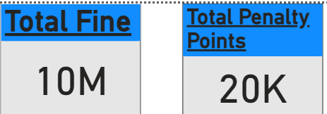

* **Total Fine :** Represents the total amount collected as fines for various traffic violations.
* **Total Penalty Points :** The total penalty points issued based on violations. Higher points indicate more severe violations.

==========================================================================

1. **Total Violations by Registration State**

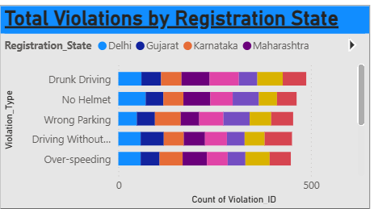

**Visual Explanation:** This chart displays the number of violations based on the vehicle’s registered state.

* **Top states with highest violations**
* This helps authorities identify regions with high non-compliance rates

==========================================================================

1. **Fine Collected by Vehicle Type**

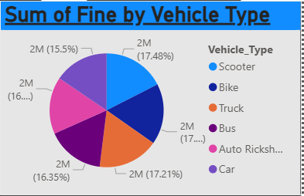

**Visual Explanation:** A bar chart showing the fine amounts collected based on vehicle categories.

* **Scooter & Bike:** High fines due to helmet-related offenses.
* **Truck & Bus:** Issues like overloading and signal jumping.
* **Auto Rickshaw:** Mostly wrong parking and overloading.
* **Car:** Violations like no seatbelt and over-speeding are common.
* This helps traffic authorities enforce vehicle-specific regulations.

==========================================================================

1. **Payment Method Distribution**

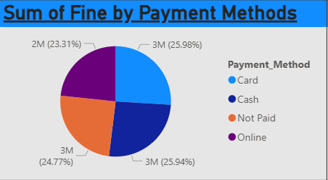

**Visual Explanation:** A pie chart illustrating how fines were paid.

* **Payment Methods:**
  + **Card Payments**
  + **Cash Payments**
  + **Online Transactions**
  + **Not Paid**
* This helps in analyzing how fine payments are handled and if digital adoption is growing.

==========================================================================

1. **Fine Distribution by Location & Penalty Severity**

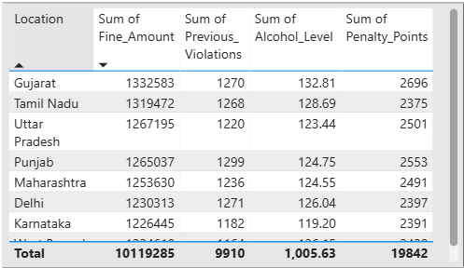

**Visual Explanation:**

This table lists:

* **Total Fine Amount** collected per state.
* **Previous Violations** – Helps track repeat offenders.
* **Alcohol Level (in drunk driving cases)** – Shows severity.
* **Penalty Points** – Determines how severe the offenses were.
* This provides insight into high-risk states and repeat violators.

==========================================================================

1. **Total Fine by Violation Type**

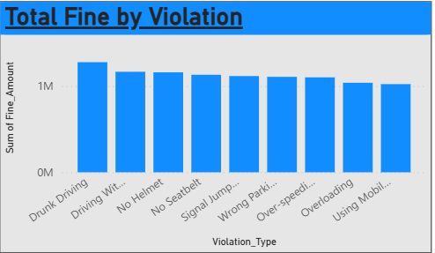

**Visual Explanation:** A stacked bar chart showcasing how much fine revenue each violation generates.

* **Drunk Driving and No Helmet generate the highest fines.**
* **Over-speeding and Using Mobile While Driving follow closely.**
* Authorities can use this data to prioritize enforcement efforts.

==========================================================================

1. **Towed Vehicles Ratio**

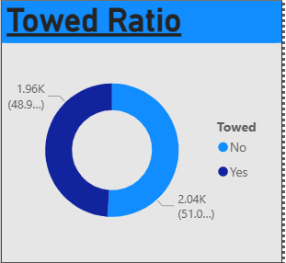

**Visual Explanation:** A percentage breakdown of vehicles that were towed after a violation.

* **51% vehicles were towed, 49% were not.**
* Indicates stricter action taken against repeat or severe offenders.

==========================================================================

1. **Decomposition tree (State, Vehicle Type, Violation Type)**

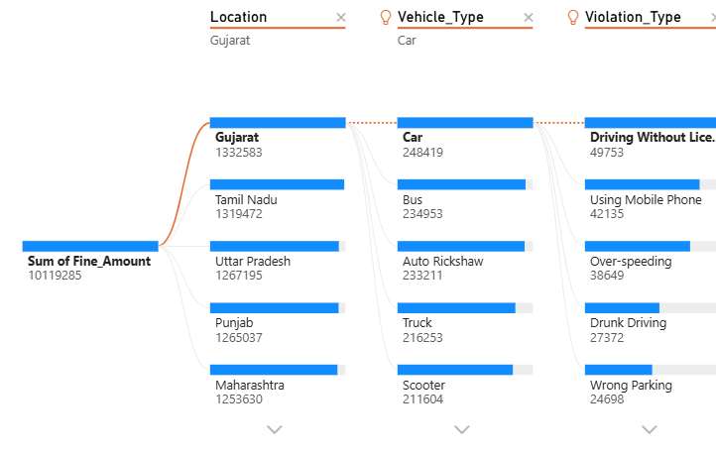

**Visual Explanation:** Filters allow users to drill down into specific states, vehicle types, and violations to analyze trends effectively.